IS:240 PROJECT 5

Name: _______________

Log on to Oracle SQL Developer using the account provided by your instructor. Query the HR sample database schema and answer the following questions.

  - Run the script I provided to create the MY_EMPLOYEE table.
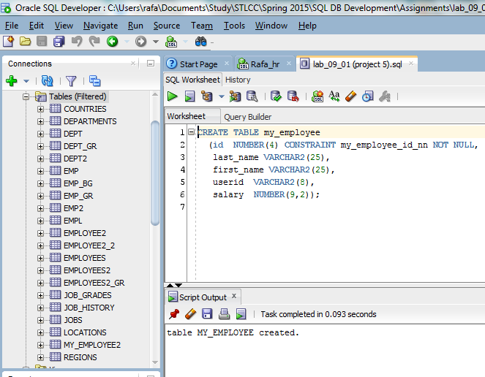

  - Describe the structure of the MY_EMPLOYEE table.
The MY_EMPLOYEE table consists of 5 columns (id, last_name, first_name, userid, and salary).
The first column is a data type NUMBER having 4 digits. Also, it has column attribute: it is a constraint named my_employee which restricts the kind of data that can be store in the column. The id column can not receive a NULL value.
The second and third columns can store data of type VARCHAR2 up to 25 characters. This kind of data type can store up to the stated number of characters, without using the rest of memory when the value uses less than 25 characters.
The fourth column is also of type VARCHAR2, but only can store up to 8 characters.
The last column is of type NUMBER and can store up to 9 characters total having 2 decimal digits.

  - Create an INSERT statement to add the following rows of data to the MY_EMPLOYEE table from the following sample data. Do not list the columns in the INSERT clause. Confirm your addition to the table.

ID | LAST_NAME | FIRST_NAME | USERID | SALARY
1 | Patel | Ralph | rpatel | 895
2 | Dancs | Betty | bdancs | 860
3 | Biri | Ben | bbiri | 1100
4 | Newman | Chad | cnewman | 750
5 | Ropeburn | Audrey | aropebur | 1550
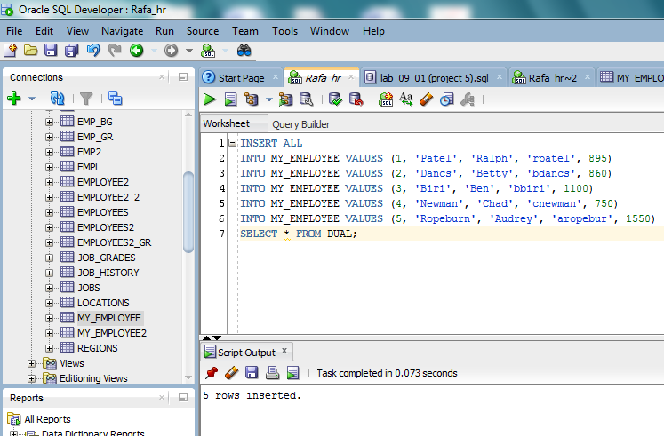
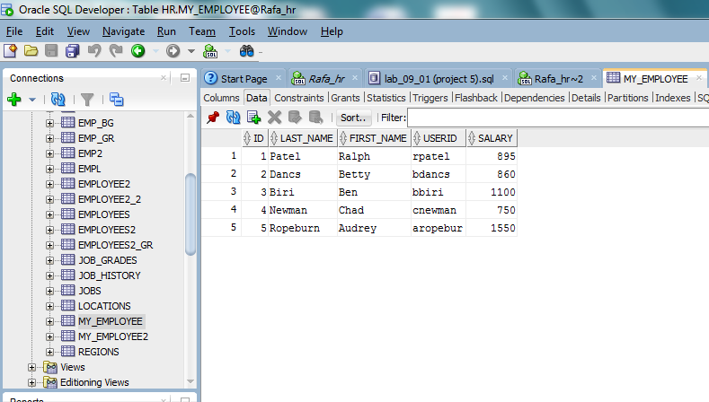

  - Change the last name of employee 3 to Drexler. Change the salary to $1,000 for all employees who have a salary less than $900. Verify your changes to the table.
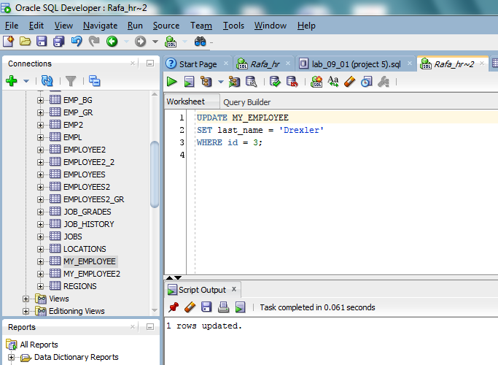
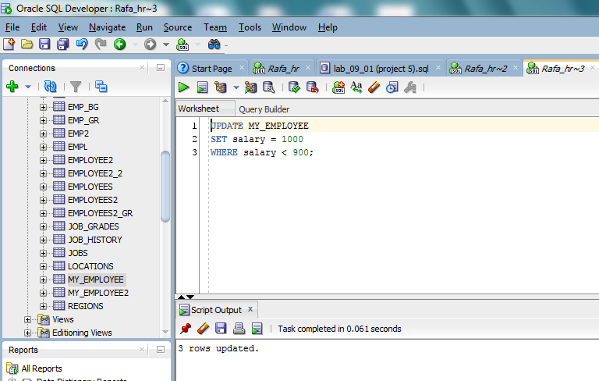
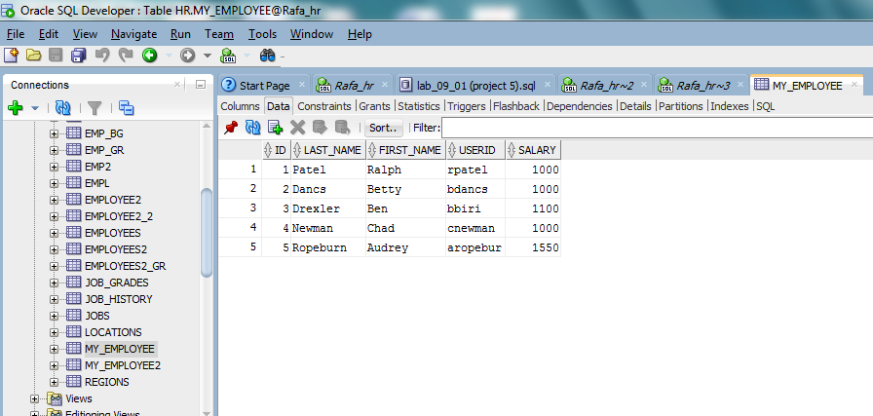

  - Delete Betty Dancs from the MY_EMPLOYEE table. Commit all pending changes.
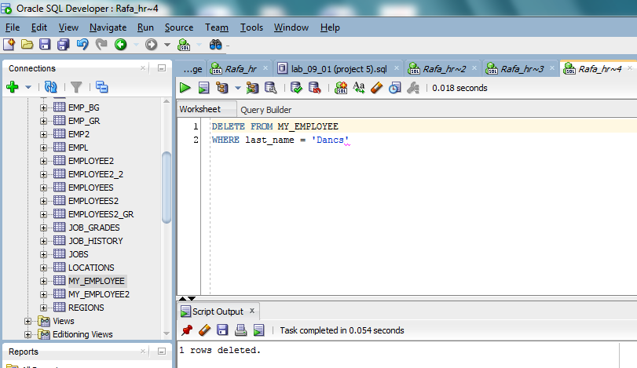
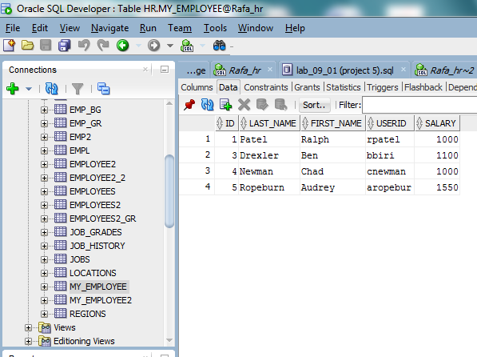
  - Create the DEPT table based on the following table instance chart. Populate the DEPT table with data from the DEPARTMENTS table. Include only columns that you need.

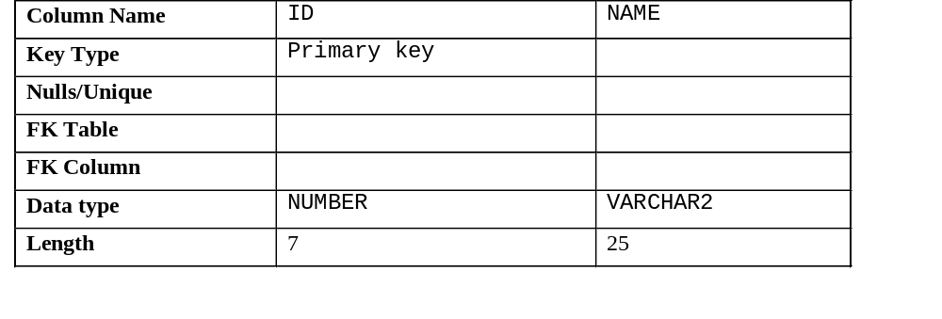

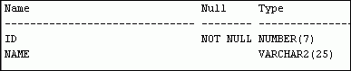

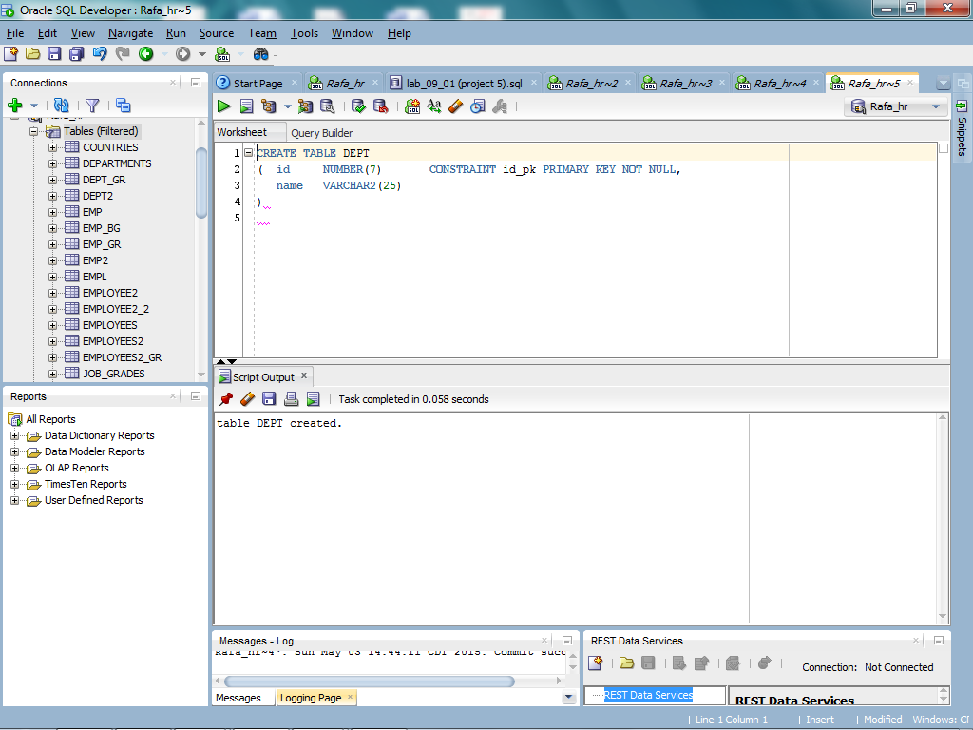
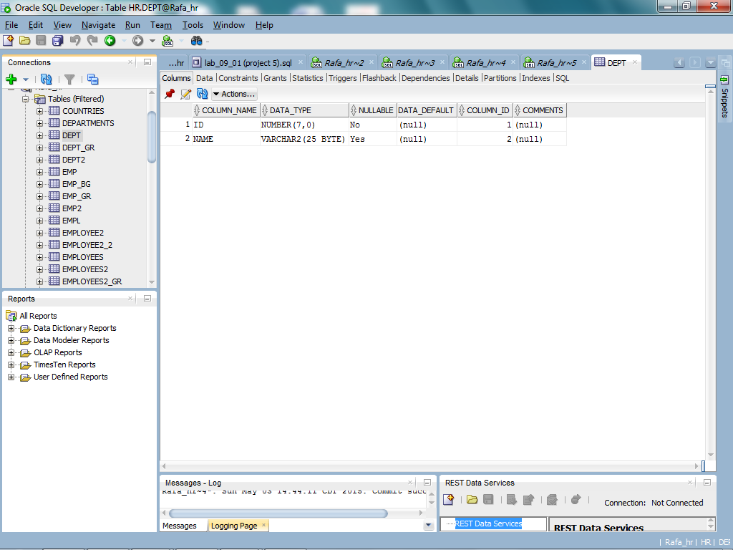
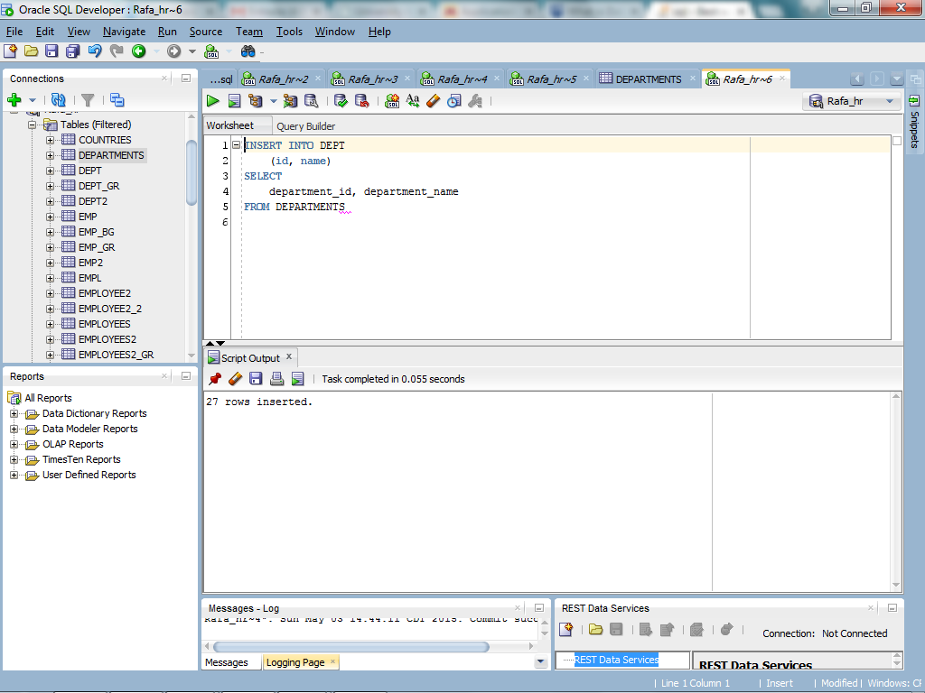
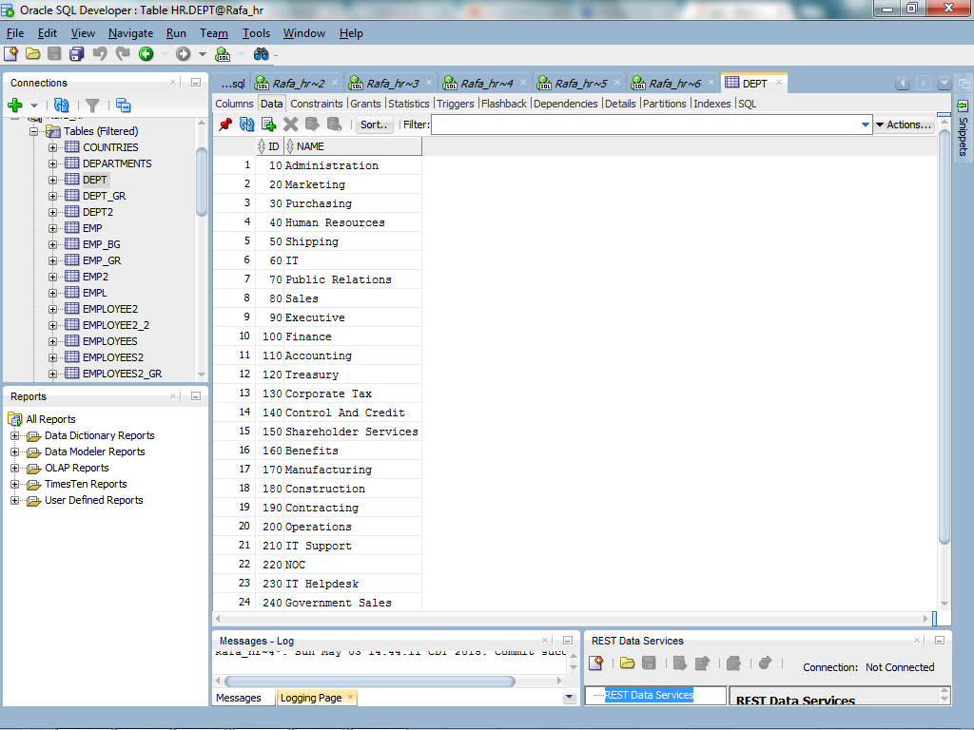

  - Create the EMP table based on the following table instance chart.
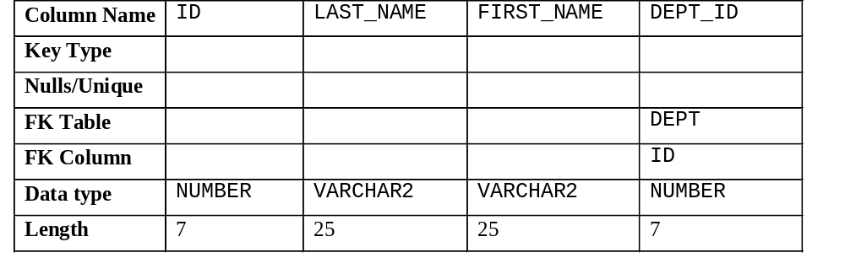

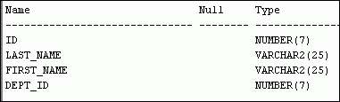
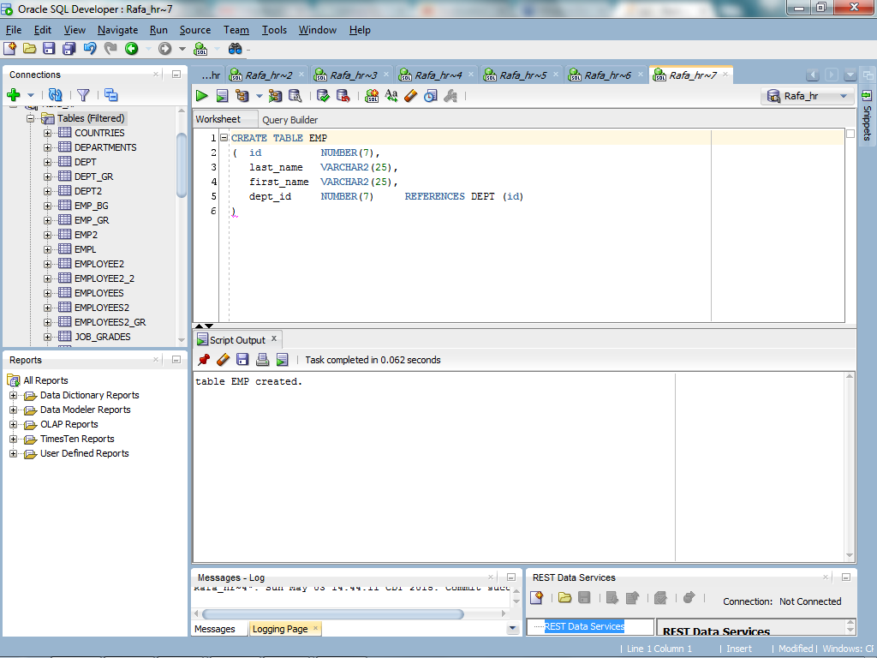
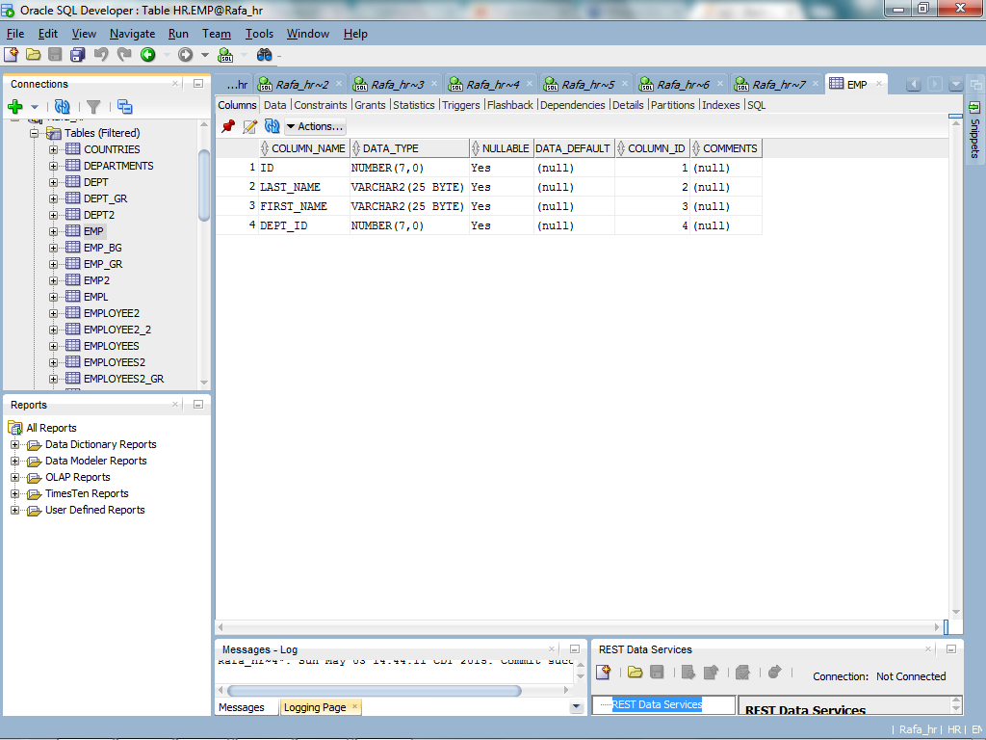

  - Create the EMPLOYEES2 table based on the structure of the EMPLOYEES table. Include only the EMPLOYEE_ID, FIRST_NAME, LAST_NAME, SALARY, and DEPARTMENT_ID columns. Name the columns in your new table ID, FIRST_NAME, LAST_NAME, SALARY, and DEPT_ID, respectively.
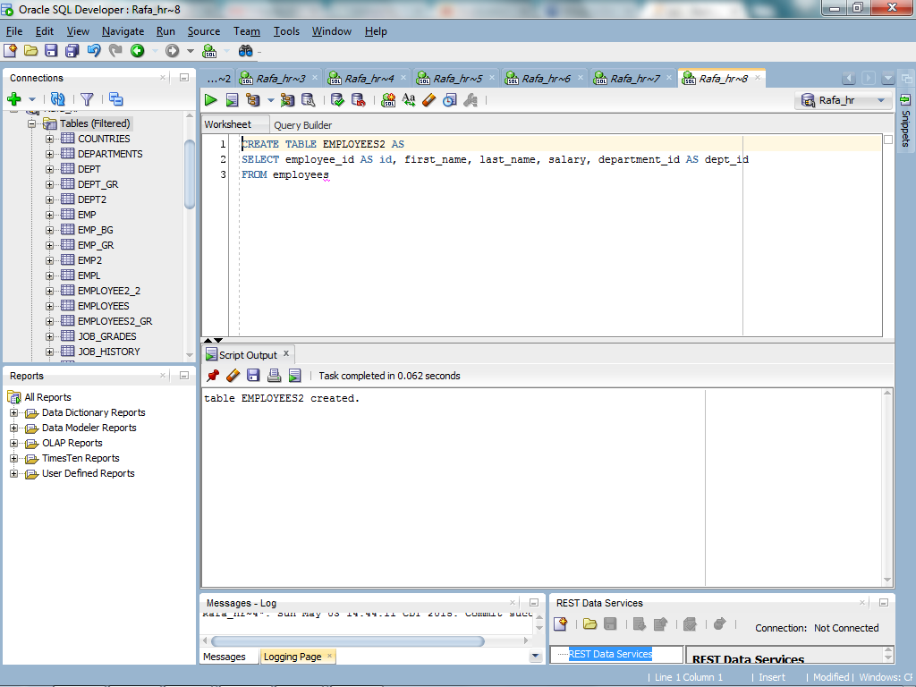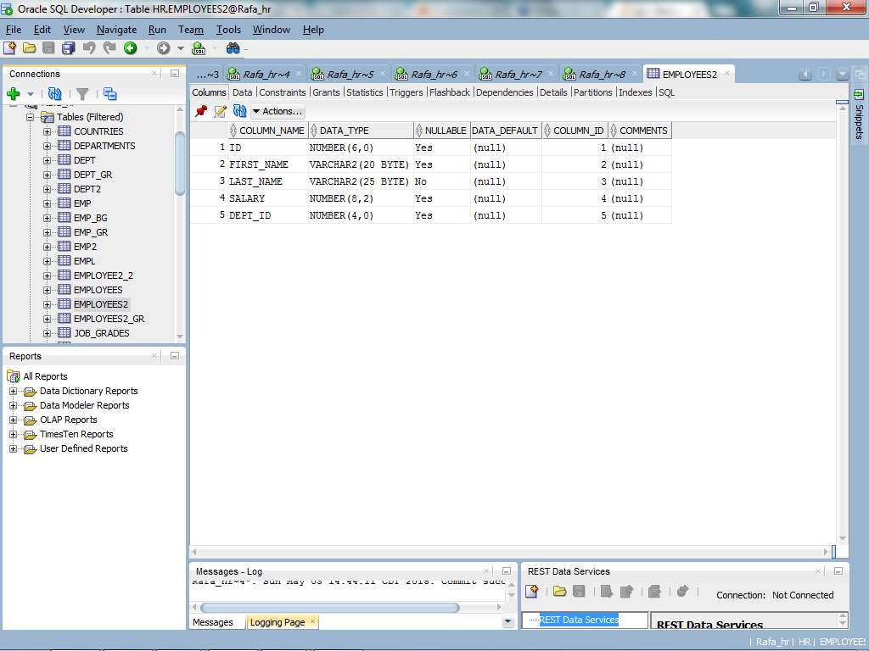

  - Alter the EMPLOYEES2 table status to read-only. Try to insert the following row in the EMPLOYEES2 table:

ID | FIRST_NAME | LAST_NAME | SALARY | DEPT_ID
34 | Grant | Marcie | 5678 | 10

What message(s) did you receive?

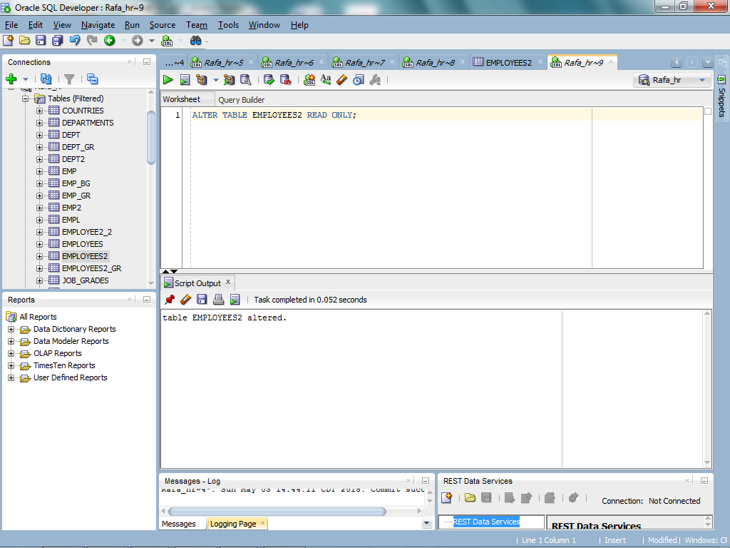
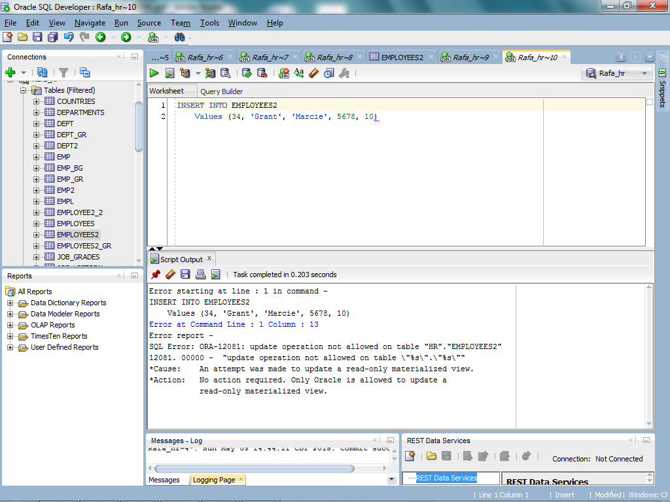

  - Revert the EMPLOYEES2 table to the read/write status. Now, try to insert the same row again. What message(s) did you receive?
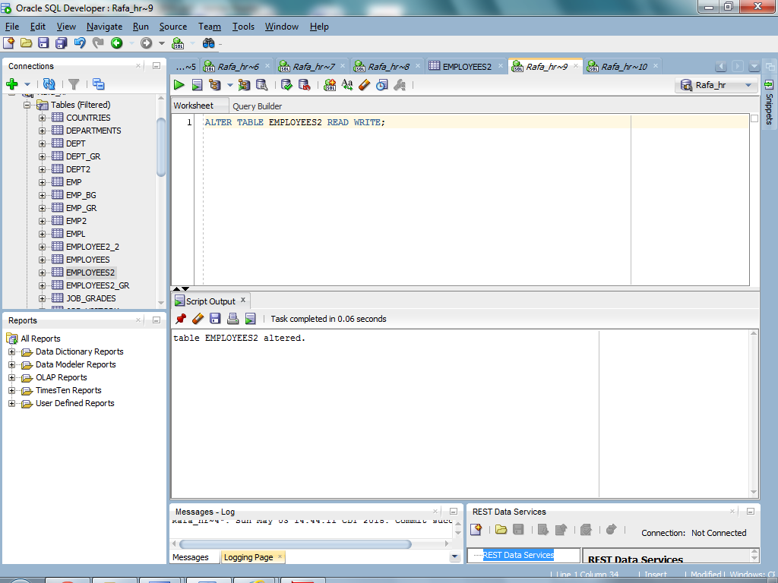
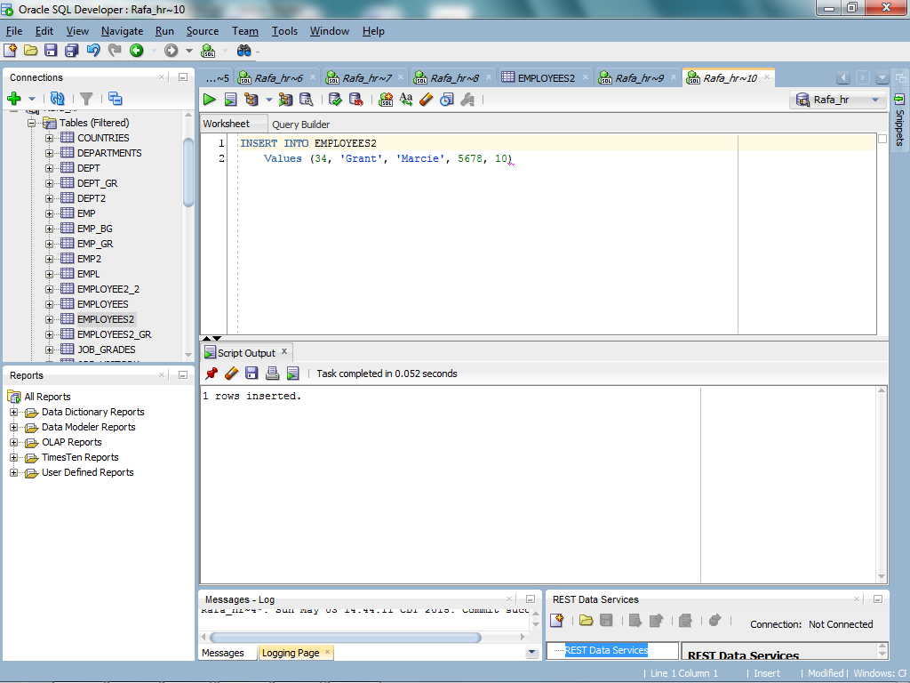

  - Department 50 needs access to its employee data. Create a view named DEPT50 that contains the employee numbers, employee last names, and department numbers for all employees in department 50. You have been asked to label the view columns EMPNO, EMPLOYEE, and DEPTNO. For security purposes, do not allow an employee to be reassigned to another department through the view. Test your view. Attempt to reassign Matos to department 80.

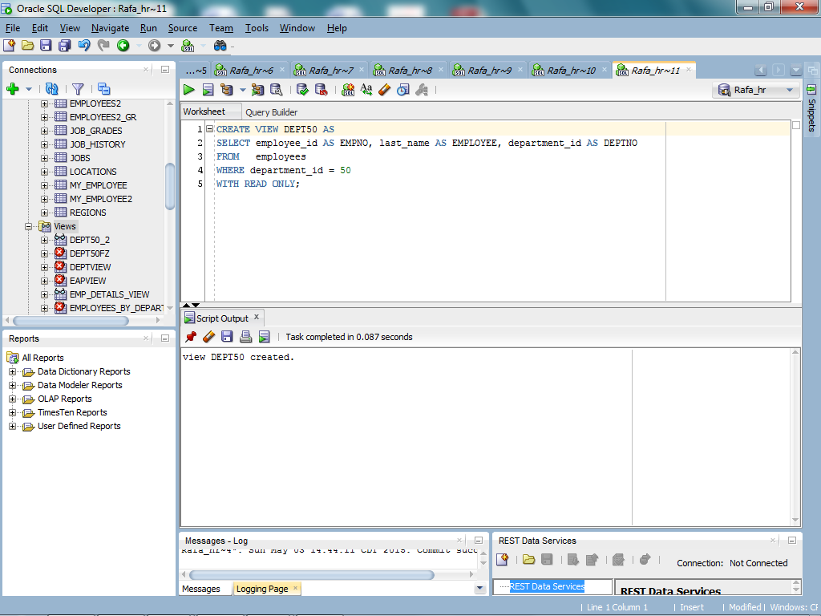
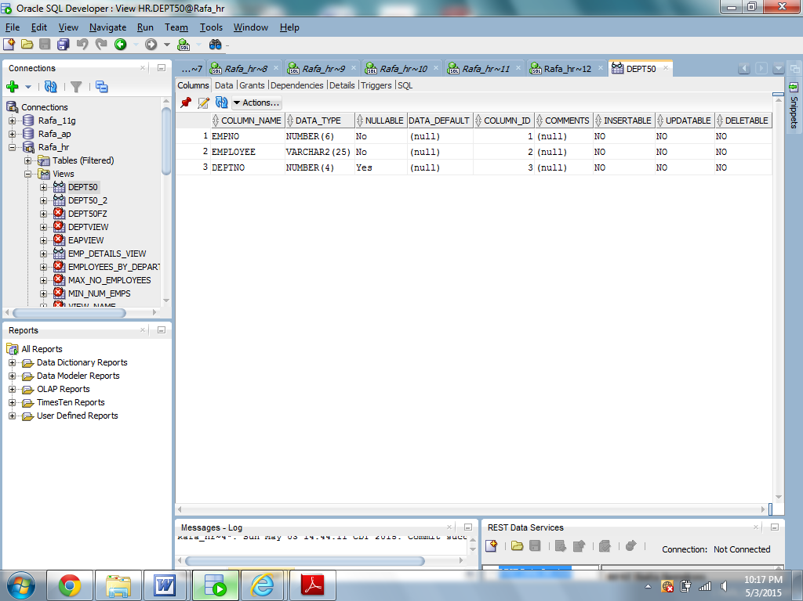
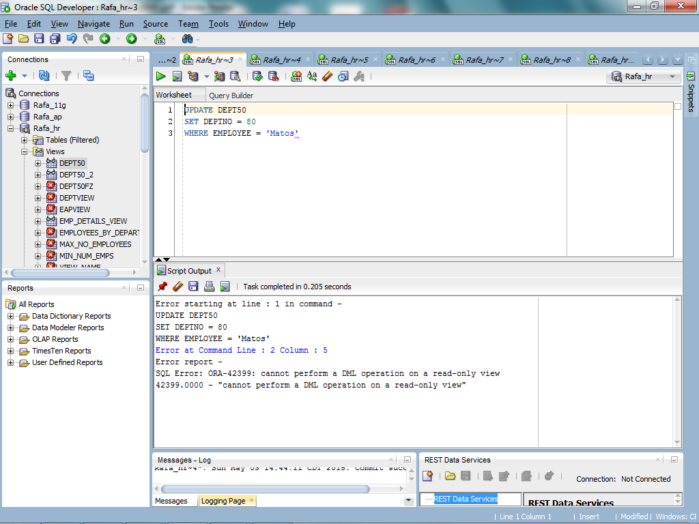

  - You need a sequence that can be used with the PRIMARY KEY column of the DEPT table. The sequence should start at 200 and have a maximum value of 1,000. Have your sequence increment by 10. Name the sequence DEPT_ID_SEQ. To test your sequence, write a script to insert two rows in the DEPT table.
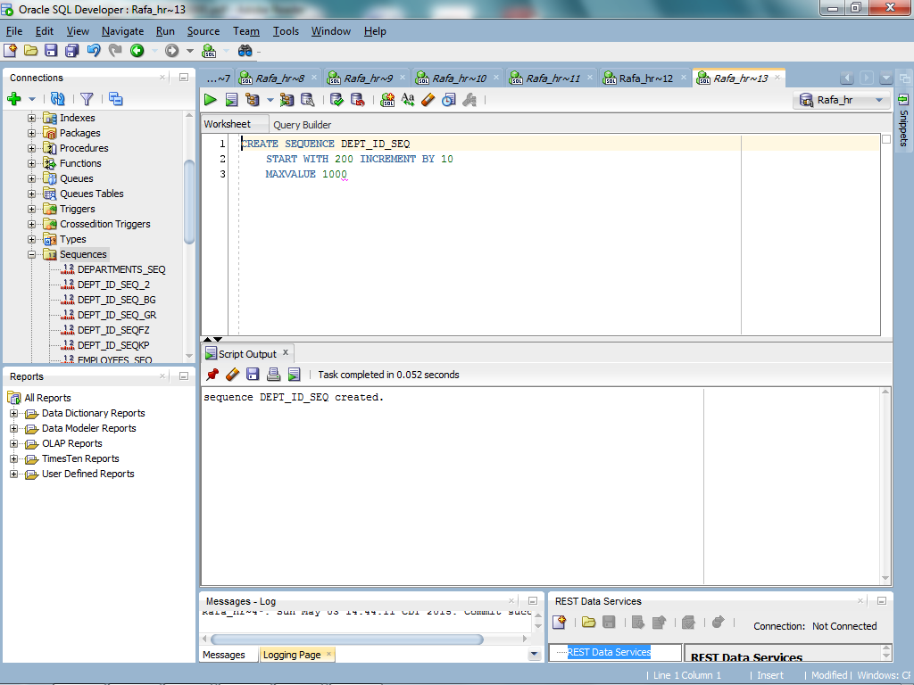
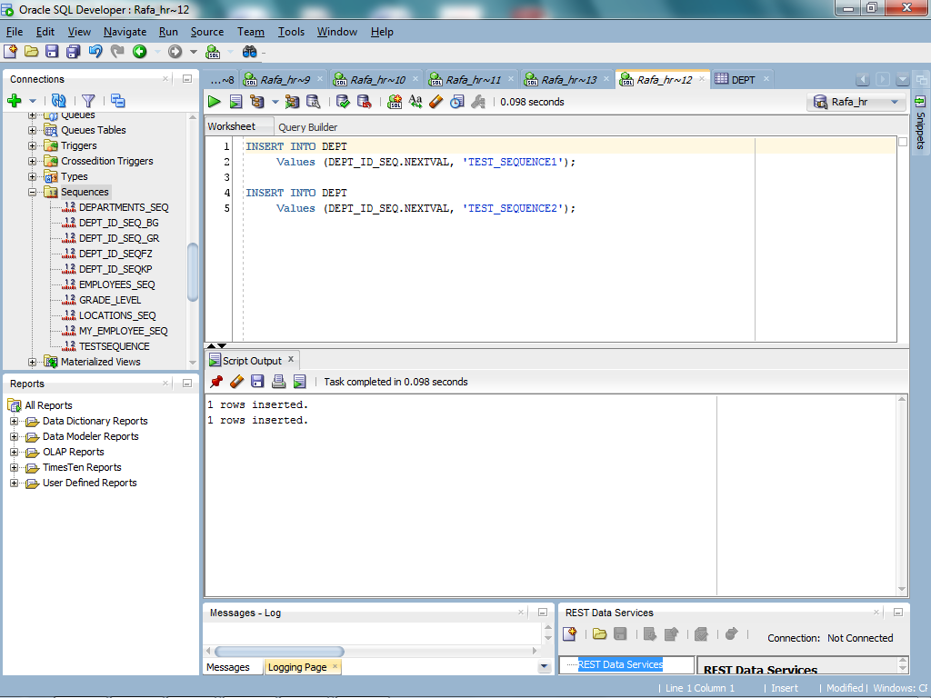
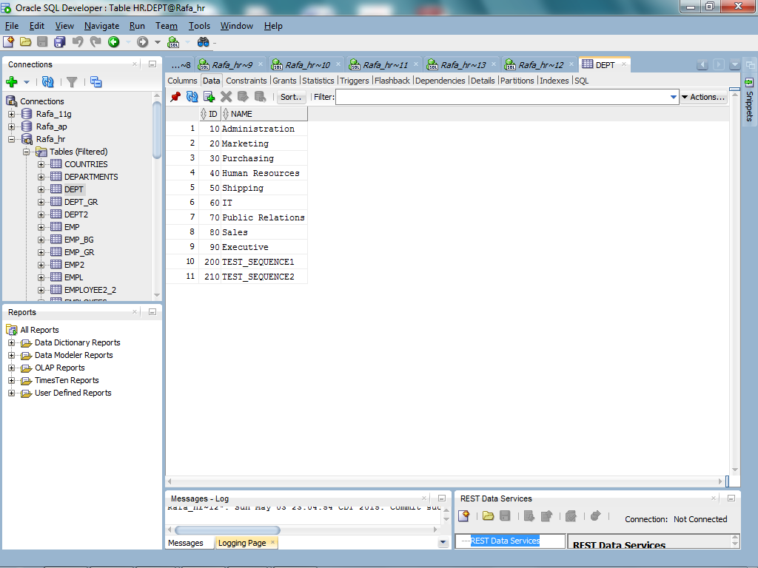

Take a screen shot of each query and its output screen(s) and paste them to your answer sheet.

